**April 24, 2013 Design updates**

1. **Report Module class diagrams**

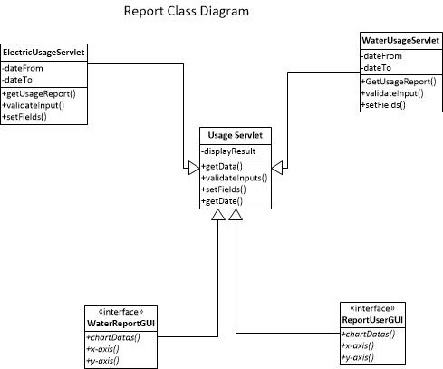

**2)**

